Capstone II Project Report

Arkansas Movies n’ Actors Website
University of Arkansas at Little Rock
IFSC 49803 Capstone II Project
Instructor: Bruce Bauer
By: Nicholas Bryan
3 December 2025

Table of Contents
Client Introduction 3
Project Purpose and Scope 3
Requirements Summary 3
System Analysis 4
Solution Framework 4
Tools and Libraries 4
System Design 5
Data Flow 8
ERD (Conceptual API Entity Model) 8
Page Navigation and User Interaction 8
Security Considerations 8
Testing and Validation 9
Ethical Considerations 10
Project Milestones 11
Conclusion 11

Client Introduction
This capstone project was developed for a client looking for a custom web application over the film heritage of Arkansas. The client’s idea was to create a modern and informative website that gathers information from two sources, which are the Encyclopedia of Arkansas and The Movie Database (TMDB) API to showcase actors originating from Arkansas and movies filmed in the state as well. This website’s target audience is 20 to 40 year olds, which is a demographic usually interested in film, culture, and digital media. The project's purpose aligns with the client’s goal of preserving and displaying Arkansas’ unique collection of films through a clean, simple, and interactive interface.

Project Purpose and Scope
The purpose of this project was to create a web-based platform that displays and organizes movie and actor information related to Arkansas. The site includes pages for movies, actors, an about section, and a homepage with featured content. The scope included front-end development, API integration, responsive design, and analytics tracking.

Requirements Summary
The project was built based on the following client requirements for the project.
Functional Requirements:
• Web-based interface using HTML, CSS, and JavaScript.
• Movies page showing 8 or more Arkansas filmed movies.
• Actors page showing at least 8 or more Arkansas actors.
• Modal pop-ups for detailed movie and actor info.
• Integration with the TMDB API.
• Data researched from encyclopediaofarkansas.net.
• Homepage featuring a random featured movie and actor.
• Links to TMDB for additional information.
Non-Functional Requirements:
• Target audience: ages 20 to 40.
• Clean, modern, simple design.
• Hosted on GitHub Pages.
• Google Analytics for user tracking.

System Analysis
The system was designed as a client-side web application hosted on GitHub Pages. The TMDB API provides real-time movie and actor data. A modular JavaScript structure was used to separate concerns. For each js file, utils.js for shared functions, movies.js for movie data logic, actors.js for actor data logic, home.js for homepage features, and details.js for modal handling.

Solution Framework
• Web based solution across devices.
• Hosted using GitHub Pages for version control.
• Client-server communication only between browser and TMDB API.

Tools and Libraries
• TMDB API for informational movie and actor data.
• Custom JavaScript modules for modularity.
• CSS custom framework for UI consistency.

System Design
The system follows a component-based page structure.
Page Layout Structure:
• index.html — hero header, featured sections, navigation cards.
Screenshot of index.html:
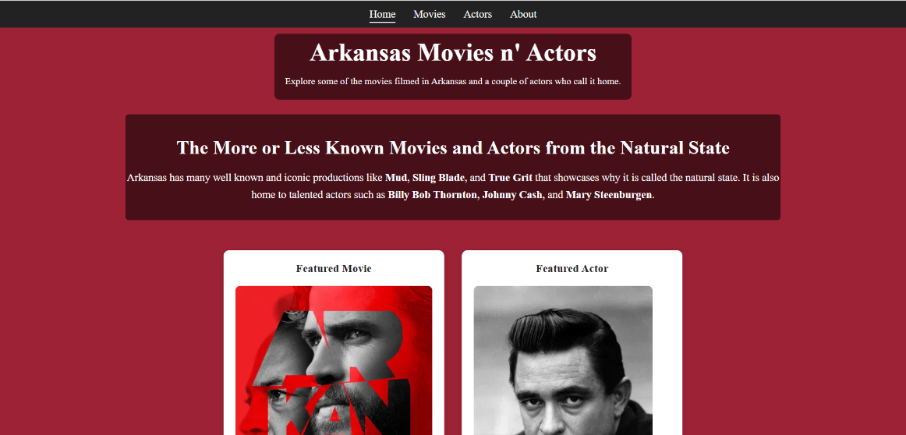
• movies.html — grid-based movie list.
Screenshot of movies.html:
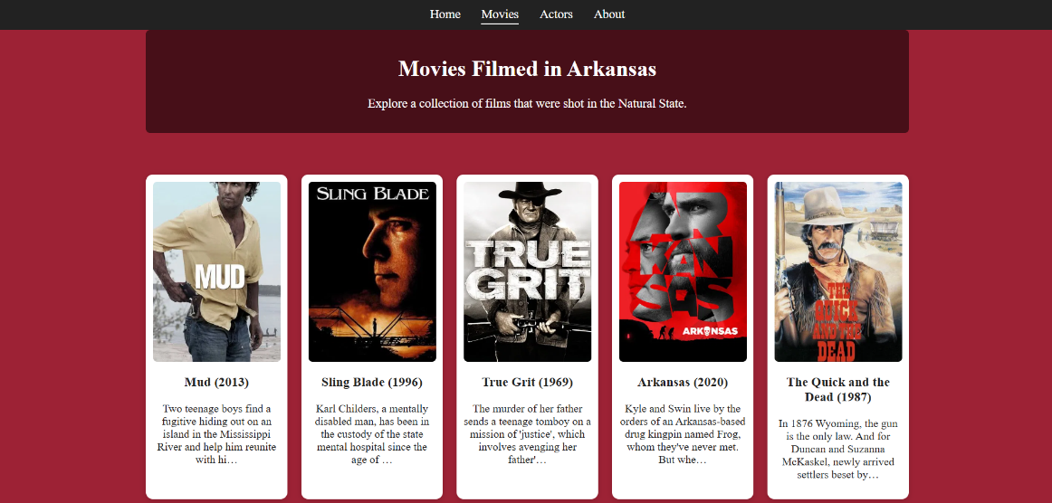
• actors.html — grid-based actor list.
Screenshot of actors.html:
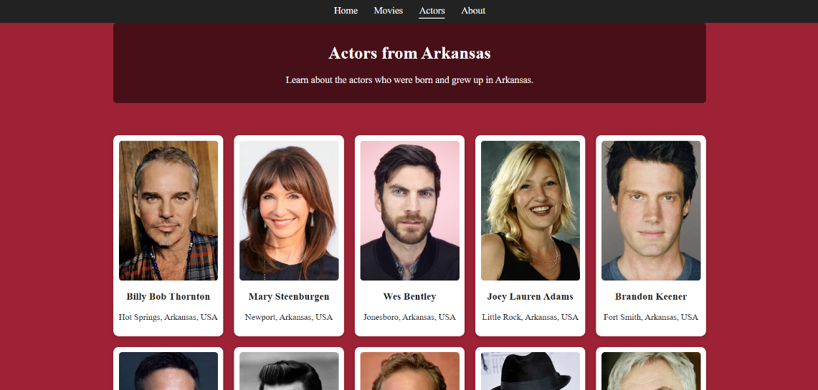
• about.html — project description.
Screenshot of about.html:
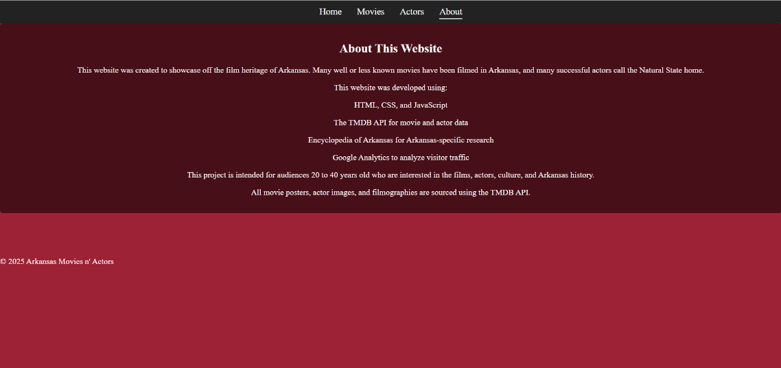

Modal System:
The modal uses a global detail-modal component and receives populated HTML from the details.js functions.
Screenshots of functions for movies and actors in detail.js to pull data from TMDB API:
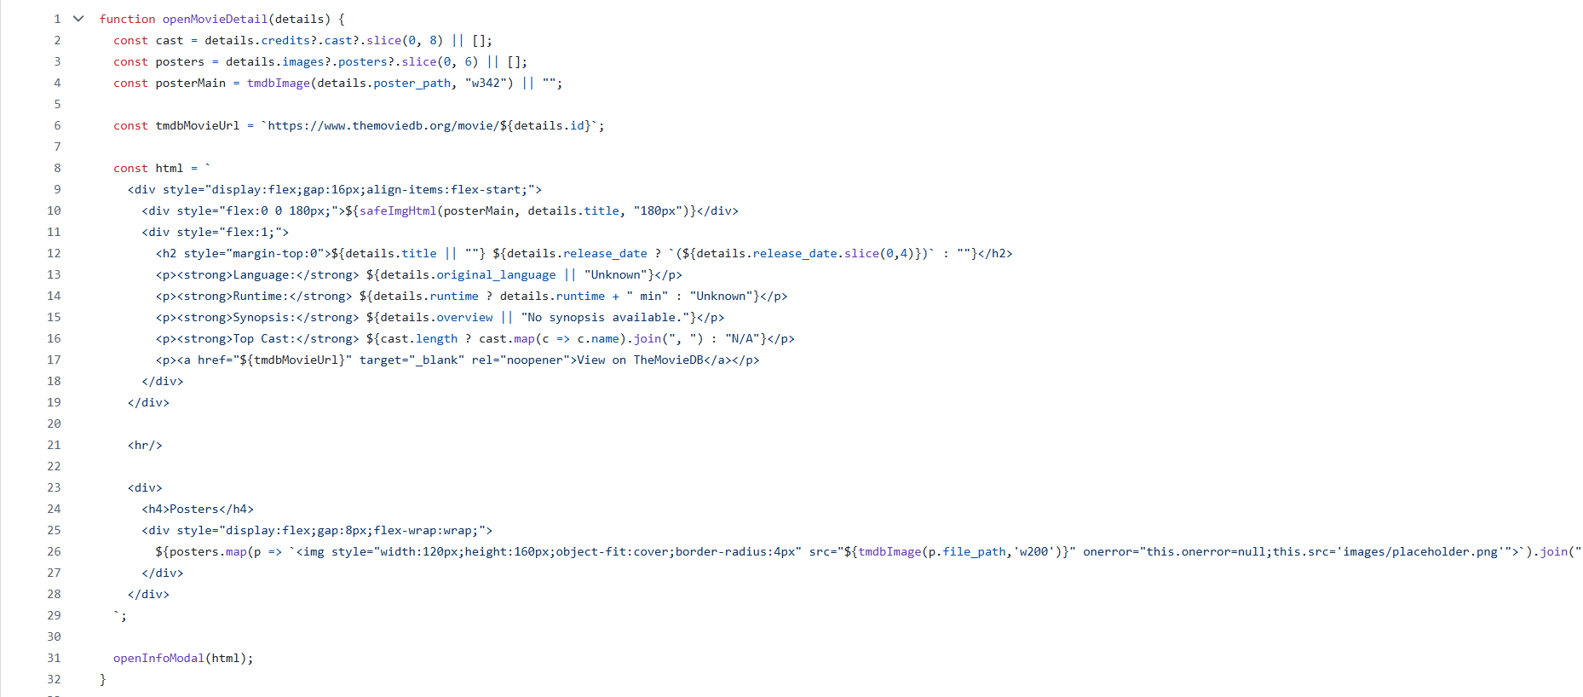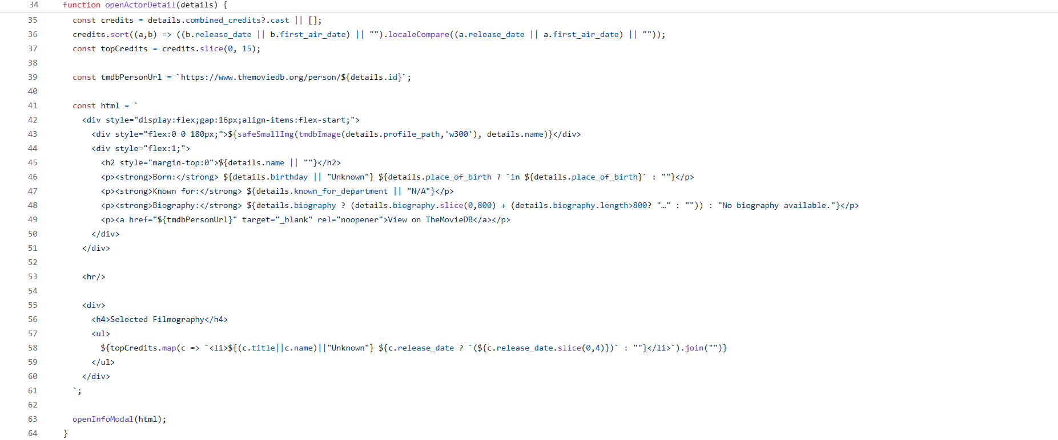

APIs Used:
• search/movie, movie/{id}, movie/{id}/credits
• search/person, person/{id}, person/{id}/combined_credits

Data Flow
1. User loads page.
2. JavaScript fetches data using TMDB API.
3. Response returns JSON movie or person objects.
4. DOM renders results.

ERD (Conceptual API Entity Model)
- TMDB entities used:
- Movie: id, title, runtime, genres, overview, poster path, release date.
- Person: id, name, biography, birthday, profile path.
- Credits: list of actors involved in a film.
- Configuration: image base URLs.
These entities form relationships like a relational database but are consumed via API.

Page Navigation and User Interaction
Navigation consists of a shared navbar linking all pages. User interactions include movie and actor grid selections, modal pop-ups, menu navigation, featured content interactions, and responsive layout adjustments.

Security Considerations
Since TMDB interactions occur client-side, the API key is secured using TMDB’s protected key system for front-end apps. No user accounts, passwords, or personal data are collected. Google Analytics collects anonymous traffic metrics for each page on the website.
Testing and Validation
Testing followed a structured approach.
Functional Tests:
• Verified TMDB fetch operations work correctly.
• Confirmed modals appear for every movie and actor.
• Homepage featured items load correctly.
• Validated navigation links across all pages.

Responsive Design Tests:
• Tested layout on desktop and mobile screens.
• Verified flexbox and grid elements scaled properly.

Error Handling Tests:
• Missing poster images replaced with placeholder.

Cross-Browser Tests:
• Chrome.
• Edge.

Analytics Validation:
• Google Analytics confirmed page visit tracking works correctly.

Ethical Considerations
Ethical concerns that were evaluated during development.
Data Ethics:
• Only public TMDB API data used.
• TMDB’s API Terms of Use followed.

User Privacy:
• No login system.
• No personal data stored.
• Google Analytics anonymous IP addresses.

Copyright:
• All images served using TMDB’s legal API-accessible CDN.
• No copyrighted assets stored in the repository.

Accessibility:
• High contrast text.
• Clear font sizes.
• Responsive layout for readability and simpleness on all devices.

Project Milestones
Step 1 – Requirements, research, project charter.
Step 2 – UI wireframes, system design document.
Step 3 – Implementation of movies and actors pages.
Step 4 – Modal system, home page, featured content.
Step 5 – Styling overhaul, image optimization.
Step 6 – Final debugging and analytics integration.

Conclusion
The Arkansas Movies & Actors Website successfully uses third-party data that is showcased in a clean, organized manner, and fulfills all client requirements. The finished product is functional, simple, easy to navigate, and ready for real audience use. The project demonstrates key effectiveness in front-end development, API integration, and web deployment. The site is deployed publicly and ready for real users. Future enhancements could include search filters, bookmarking features, or custom Arkansas film history content.

